**Name: Akshay kumar**

**Roll no: 24k-0911**

**Pf lab task 3**

**Task 1: Explain the output of this C program. Why the wrong value is being displayed in the output?**

**#include<stdio.h>**

**main(){**

**int testinteger=2200000000;**

**printf("number is %d",testinteger);**

**}**

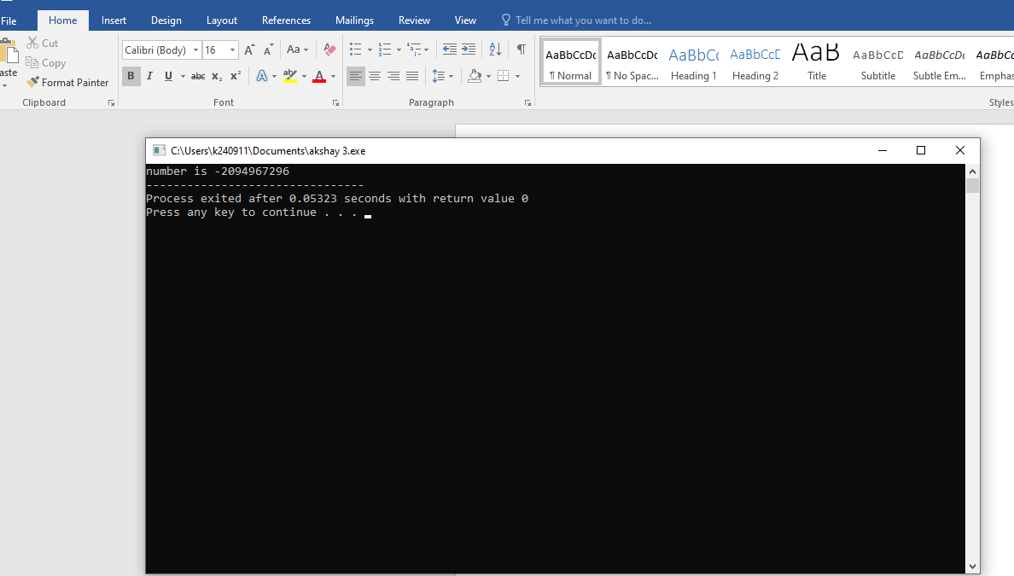

**Reason: output has a error because of intput is more than the max integer limit.**

**Task 2 Write a C program that finds the largest of three numbers entered by the user.**

**#include<stdio.h>**

**main(){**

**int num1;**

**int num2;**

**int num3;**

**int largestno;**

**printf("enter the first number:");**

**scanf("%d",&num1);**

**printf("enter the 2nd number:");**

**scanf("%d",&num2);**

**printf("enter the 3rd number:");**

**scanf("%d",&num3);**

**if (num1>num2)**

**{printf ("num1 is largest");}**

**else if(num1>num3)**

**{printf("num1 is largest");}**

**}**

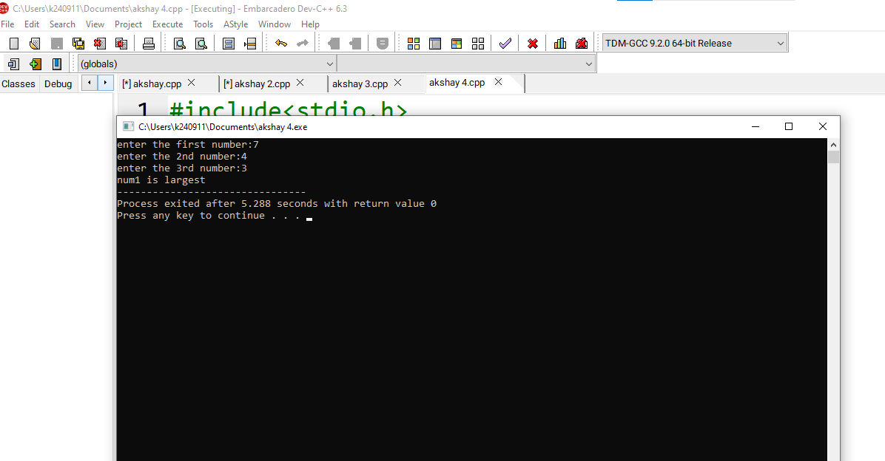

**Task 3: A travel agency asks you to develop a program in C that can convert an amount from one currency to another. The user should input the amount in their local currency and the conversion rate for the desired foreign currency. The program should then output the**

**equivalent amount in the foreign currency.**

**#include<stdio.h>**

**main(){**

**int amount;**

**int conversionrate;**

**int newamount;**

**printf("enter the amount");**

**scanf("%d",&amount);**

**printf("enter the conversion rate");**

**scanf("%d",&conversionrate);**

**newamount=amount*conversionrate;**

**{printf("%d",newamount);}**

**}**

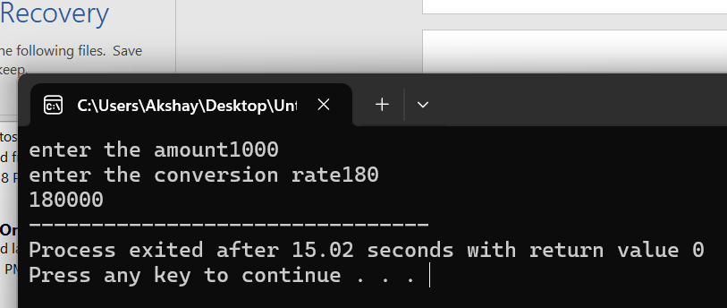

**Task 4: Write a C program that determines whether a number provided by the user is even or odd.**

**#include<stdio.h>**

**main(){**

**int num;**

**printf("enter the number");**

**scanf("%d",&num);**

**if (num%2==0)**

**{printf("num is even");}**

**else**

**{printf("num is odd");}**

**}**

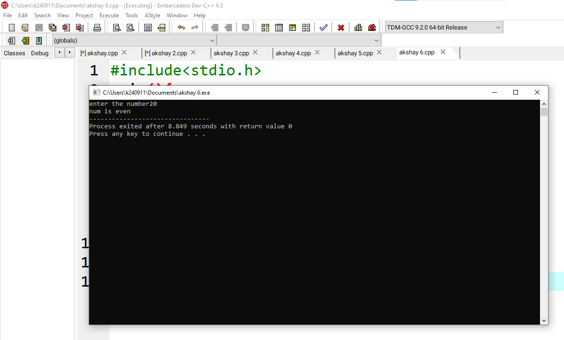

**Task 5:** **Write a C program to calculate the discounted price of an item based on original price between Rs.100 and Rs. 50,000. Discount rate between 5% and 30%. Calculate the final price after applying the discount. Validate inputs and provide error messages if they are out of range.Display the final price after discount.**

**Final Price = Original Price * (1 – Discount Rate / 100)**

#include <stdio.h>

int main() {

float originalPrice, discountRate, finalPrice;

printf("Enter the original price (Rs. 100 to Rs. 50,000): ");

scanf("%f", &originalPrice);

if (originalPrice < 100 || originalPrice > 50000) {

printf("Error: Original price must be between Rs. 100 and Rs. 50,000.\n");}

printf("Enter the discount rate (5%% to 30%%): ");

scanf("%f", &discountRate);

if (discountRate < 5 || discountRate > 30) {

printf("Error: Discount rate must be between 5%% and 30%%.\n");

}

finalPrice = originalPrice * (1 - discountRate / 100);

printf("Final price after discount: Rs. %.2f\n", finalPrice);

}

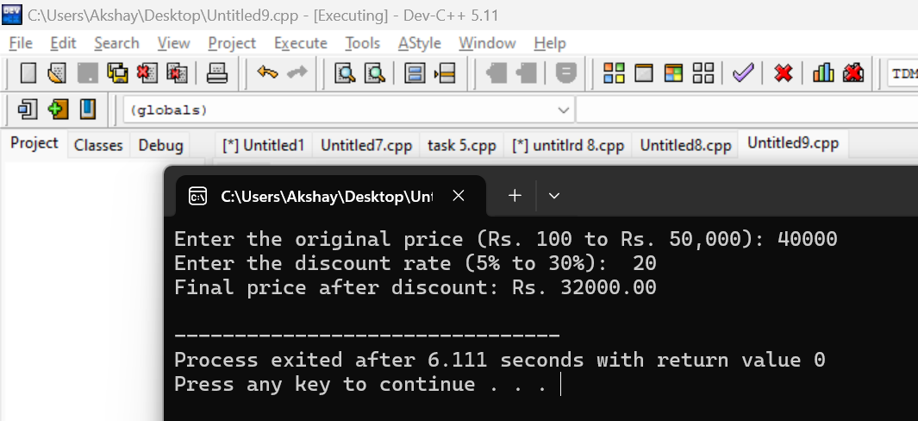

**Task 6:** **Write a C program to calculate the volume of a cylinder given its radius and height. Use the formula: Volume = π r2 h where π is approximately 3.14159. Format the result to 3 decimal places.**

**#include<stdio.h>**

**main(){**

**int r;**

**int h;**

**float pie,volume;**

**printf("enter the r");**

**scanf("%d",&r);**

**printf("enter the h");**

**scanf("%d",&h);**

**printf("enter the pie");**

**scanf("%f",&pie);**

**volume=pie*h*r*r;**

**printf("%f",volume);**

**}**

